# Equal Weighted Portfolio - Python Solution

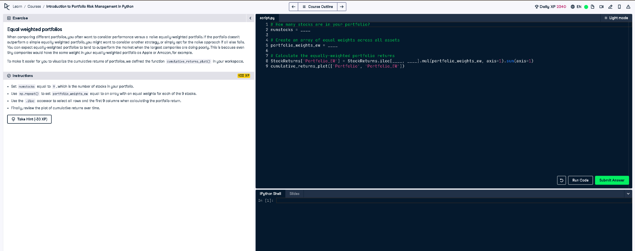

Figure: Screenshot of the exercise on Equal Weighted Portfolios

## Full Python Answer

# How many stocks are in your portfolio?  
numstocks = 9  
  
# Create an array of equal weights across all assets  
portfolio_weights_ew = np.repeat(1/numstocks, numstocks)  
  
# Calculate the equally-weighted portfolio returns  
StockReturns['Portfolio_EW'] = StockReturns.iloc[:, 0:9].mul(portfolio_weights_ew, axis=1).sum(axis=1)  
  
# Plot the cumulative returns of both weighted and equal-weighted portfolios  
cumulative_returns_plot(['Portfolio', 'Portfolio_EW'])

## Simple 50-Word Explanation

This code creates an equally weighted portfolio where each of the 9 stocks has the same weight (1/9). It multiplies each stock's return by its weight, adds them up, and calculates daily returns. Finally, it plots both the weighted and equal-weighted cumulative returns over time for comparison.